Lab 8 - 89296 Tomás Batista

The repository that I’m showing was used on IES (Introdução à Engenharia de Software), we were 4 members.
We applied a branch-feature technique on our repository. Then, every branch, and the code owner, had to pull request to the main branch. The other members of the team had to review and approve.
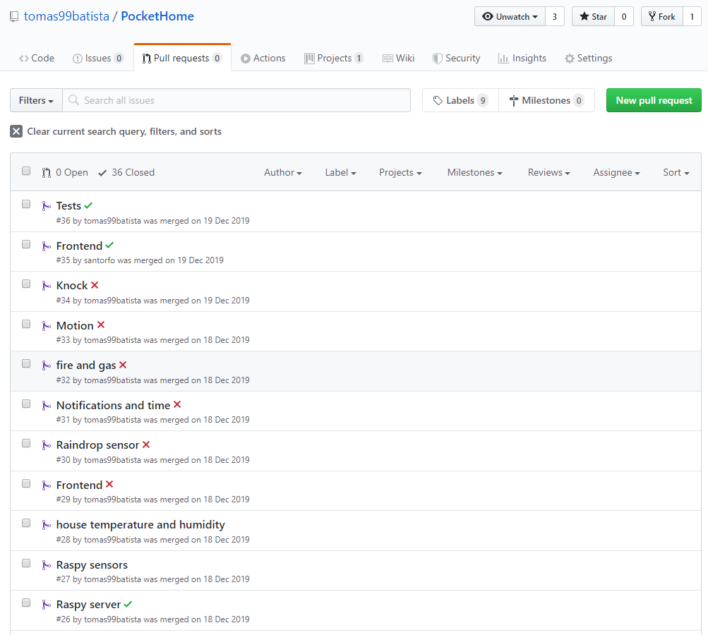
Fig. 1 - Pull requests

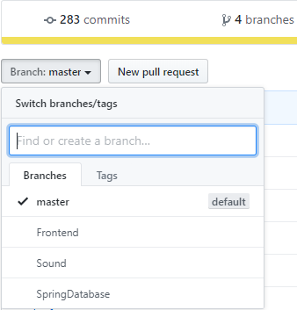

Fig. 2 - Branches
We always made a little resumé of what we implemented and, if applicable, the next thing to-do.
Fig. 3 - Commit messages
Additionally we added Codacy to our project to review and give us feedback about code quality and errors.
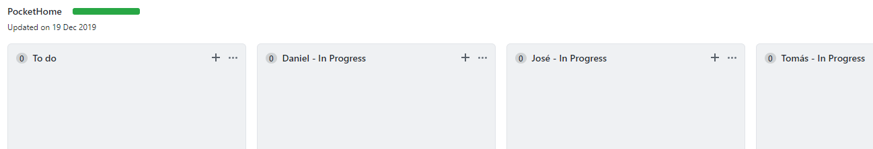
Fig. 4 - Project Board

To control the workflow and the things need to be done we implemented a “TO-DO | DOING | DONE” board that was divided by member so they could “drag” the task they add to-do to their board.
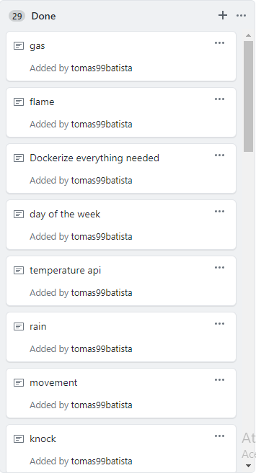

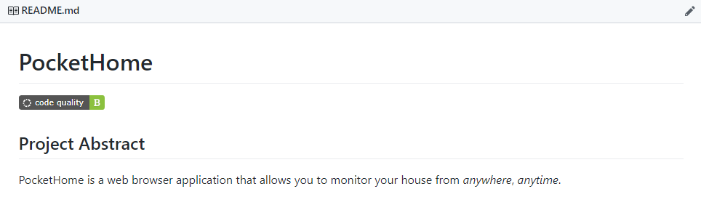
Fig. 5 - Tasks done
Fig. 6 - Codacy code quality

